YEAR 12 CHEMISTRY

TEST 3 Redox and Electrochemical Cells

ANSWERS

MULTIPLE CHOICE ANSWER SHEET

Questions 1-15

1 | a  b  c  d  |  | 9 | a  b  c  d 
2 | a  b  c  d  |  | 10 | a  b  c  d 
3 | a  b  c  d  |  | 11 | a  b  c  d 
4 | a  b  c  d  |  | 12 | a  b  c  d 
5 | a  b  c  d  |  | 13 | a  b  c  d 
6 | a  b  c  d  |  | 14 | a  b  c  d 
7 | a  b  c  d  |  | 15 | a  b  c  d 
8 | a  b  c  d 
(15 marks)

PART 2 : SHORT ANSWER (17 Marks)

Answer questions in the space provided. Note that NOT all questions carry equal marks.

1. This question refers to the diagram and information below. Use labels to show on the diagram, the
(a) anode;
(b) cathode;
(c) direction of the electron flow, and
(d) direction of migration of positive ions in the salt bridge.

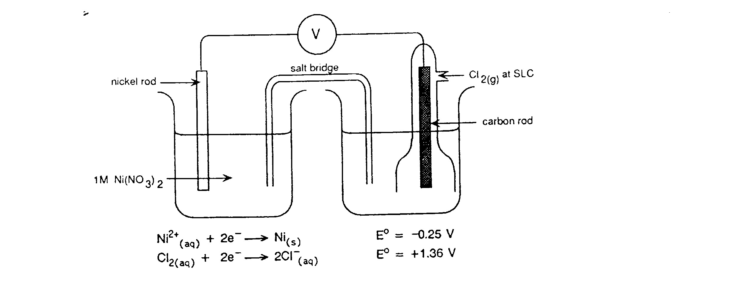
(d) +‘ve ion flow
(a) ANODE
(b) CATHODE
(c) e⁻ flow

(4 marks)

Write the overall chemical equation for this electrochemical cell:

Cl₂(aq) + Ni(s) 2Cl⁻ (aq) + Ni²⁺ (aq)
(1 mark)

2. A student was given freshly prepared solutions of iron (II) sulfate, sodium bromide, bromine water and acidified potassium permanganate. She carried out the tests shown in (a), (b) and (c) below. For each test, record any observed colour changes she may have seen. (1 for each obs’n)

(a) Small amounts of the iron (II) sulfate solution and bromine water were mixed and shaken.

Observation: Pale green and orange solutions form a brown solution

(b) Small amounts of the iron (II) sulfate solution and potassium permanganate solutions were mixed and shaken.

Observation: pale green and purple solutions change to orange/brown

(c) Small amounts of potassium permanganate solution and sodium bromide were mixed and shaken.

Observation: Purple solution changes to orange

(d) From these results, state below, which of the four solutions contained:

(i) the most powerful oxidant Potassium permanganate
(ii) the most powerful reductant Iron (II) sulfate (4 marks)

- For each of the reactions below, complete the table that follows.
In each equation, states are NOT required.

- When a solution containing potassium dichromate (K₂Cr₂O₇) and sulfuric acid is added to a solution of tellurium(IV) oxide (TeO₂), the mixture turns deep green which indicates that chromium(III) ions are produced. Every reduction must be accompanied by oxidation ,so the TeO₂ must have been oxidised. The only known higher oxidation state for Te is (+6), so presumably an ion similar to SO₄²⁻ is produced. Work out the equations below. (4 marks)

Reduction half-equation

Cr₂O₇²⁻ + 14 H⁺ + 6 e⁻ → 2 Cr³⁺ + 7 H₂O (1)

Oxidation half-equation

TeO₂ + 2 H₂O → TeO₄²⁻ + 4 H⁺ + 2 e⁻ (1)

Redox equation

Cr₂O₇²⁻ + 2 H⁺ + 3 TeO₂ → 2 Cr³⁺ + H₂O + 3 TeO₄²⁻ (2)

(only 1 mark if correct, but using wrong equations from above)

- When a solution of potassium bromide (KBr) is added to a solution containing potassium bromate (KBrO₃) and sulfuric acid, the mixture turns orange which indicates that bromine is a reaction product. Work out the equations below. (4 marks)

Reduction half-equation

2 BrO₃⁻ + 12 H⁺ + 10 e⁻ → Br₂ + 6 H₂O (1)

Oxidation half-equation

2Br⁻ → Br₂ + 2e⁻ (1)

Redox equation

2 BrO₃⁻ + 12 H⁺ + 10 Br⁻→ 6 Br₂ + 6 H₂O (2)

(only 1 mark if correct, but using wrong equations from above)
PART 3: CALCULATION (8 marks)

An experiment was carried out to determine the amount of active chlorine in a sample of household bleach. The chlorine is present in the form of sodium hypochlorite (NaClO).
The hypochlorite (ClO−) is reacted with aqueous potassium iodide to liberate iodine:
The liberated iodine produced is then titrated against sodium thiosulfate (Na₂S₂O₃):
5.00 mL of the bleach solution was added to 250.0 mL volumetric flask. Approximately 25 mL of 0.5 mol L⁻¹ potassium iodide was added, along with approximately 25 mL of 2.00 mol L⁻¹ sulfuric acid. The flask was filled to 250.0 mL with distilled water.
25.00 mL of the resulting solution was titrated against 0.100 mol L⁻¹ sodium thiosulfate and required 15.50 mL of this solution to remove all the iodine produced.

- Calculate the amount (in moles) of thiosulphate ion needed to react with the liberated iodine in the titration flask.
[2 marks]
n(S₂O₃²⁻) = 0.1 x 0.0155 = 1.55 x 10⁻³ mol

- Calculate the amount (in moles) of iodine in the titration flask and hence the amount of hypochlorite that liberated this iodine. [2 marks]

n(I₂) = ½ x 1.55 x 10⁻³ = 7.75 x 10⁻⁴ mol
n(ClO⁻) = n(I₂) = 7.75 x 10⁻⁴ mol

(c) Calculate the amount (in moles) of hypochlorite in the 250.0 mL volumetric flask.
[2 marks]
n(ClO⁻) = 250/25 x 7.75 x 10⁻⁴ = 7.75 x 10⁻³ mol

(d) Calculate the concentration of sodium hypochlorite ions in the original bleach in:
(i) mol L⁻¹ (ii) g L⁻¹ [2 marks]
(i) n(NaClO) = n(ClO⁻) = 7.75 x 10⁻³ mol
c(NaClO) = 7.75 x 10⁻³/0.005 = 1.55 molL⁻¹

(ii) c(NaClO) = 1.55 x 74.44 = 115 gL⁻¹

END OF TEST Total: 40 Marks

